Original Research

The title of the article contains the formal object, material, and context.
written in a maximum of 15 words (font Times New Roman, 16pt, bold)

Author Name, Primary University Affiliation, Country
Author Name, Primary University Affiliation, Country
Author Name, Primary University Affiliation, Country
Author Name, Primary University Affiliation, Country
Author Name, Primary University Affiliation, Country

Received: xx/xx/xxxx Accepted: xx/xx/xxxx Published: xx/xx/xxxx
Abstract (Written in a maximum of 200 words, using English, font Times New Roman, 11pt, space 1).
Background: Provides a concise explanation of the significance and urgency of the issue or phenomenon under investigation by identifying gaps between empirical conditions and existing conceptual frameworks.
Purpose: Articulates the research objectives clearly by defining the focus of the study and specifying the intended contributions to addressing the identified research problem.
Method: Outlines the research design, approach, data sources, as well as the procedures for data collection and analysis in a clear, systematic, and concise manner.
Findings: Presents the principal findings succinctly by highlighting key patterns, relationships, or results that directly respond to the formulated research problem.
Significance: Elucidates the contributions of the study in conceptual, methodological, and policy dimensions, while offering recommendations or directions for future research.
Keywords: Minimum 3 keywords and maximum 5 keywords (font Times News Roman, 11pt, space 1)

Introduction (Times New Roman, 12 pt, bold for all main titles)
The introduction is written using Times New Roman font, 11 pt, with 1.15 spacing. It consists of four paragraphs, with each paragraph comprising a minimum of 10 lines and a maximum of 15 lines. The first paragraph presents social facts that demonstrate the significance of the selected topic or phenomenon, highlighting its relevance and urgency for scholarly inquiry. The second paragraph discusses existing literature, identifying gaps, limitations, or shortcomings in previous studies that have addressed the issue or phenomenon under investigation. The third paragraph provides a critical evaluation of prior research, serving as the foundation for positioning the focus and contribution of the present study. The fourth paragraph outlines the research questions and articulates the arguments or hypotheses proposed to achieve the objectives of the study.

Literature review
The literature review is written using Times New Roman font, 11 pt, with 1.15 spacing, and each paragraph ranges from 10 to 15 lines. It comprises a minimum of four and a maximum of six paragraphs, presenting conceptual debates derived from the three main keywords of the study: the formal object, the material object, and the context applied in the main title. The discussion focuses on defining key terms, clarifying understanding, and explaining the concepts or theories employed, while also providing an evaluative perspective by elaborating on their categorization, aspects, methods, and relevant examples.

Method
The method section is written using Times New Roman font, 11 pt, with 1.15 spacing. Each paragraph should consist of at least 10 lines and a maximum of 15 lines to ensure clarity and depth of explanation. It must include six main elements. First, it explains why the authors chose the issue or phenomenon as the focus of the study. Second, it describes the type of study and the data used. Third, it explains the data sources and how they were selected. Fourth, it outlines the techniques or methods used for data collection. Fifth, it describes the process and stages of data analysis that have been carried out. Sixth, it explains the ethical justification of the data collection, usage, and analysis processes in accordance with academic research ethics standards.

Findings
Findings are written using Times New Roman font, 11pt, Spacing 1.15. The findings must be relevant to the focus or research question posed and written in a minimum of 10 and a maximum of 15 lines. The findings must include three characters that explain the issue or phenomenon being raised or studied. First, the findings must describe the forms of the issue or phenomenon being raised or studied in detail. Second, the findings must explain the factors that influence the emergence of issues or phenomena being raised or studied critically. Third, the findings must show the implications of the issues or phenomena being raised or studied in a transformative way.
Authors must adapt to the journal’s format when presenting the results, using tables, figures, and direct interview quotations. Direct quotations from interview narratives should be done in the following way:
"The community favours the Backwards and Forward Indonesia Party because it is pro-poor. The party often gets the highest votes in every general election, so there are many leaders born from this party (Informant’s initial name, age)". (font Times News Roman, 11pt, Spacing 1.15)

Findings presented in tables or figures must adhere to journal writing standards to ensure the data are presented clearly and systematically. Prior to each table, an introductory paragraph of 10-15 lines should be provided to provide context and explain the relevance of the data presented. Following the table, two paragraphs must be included: the first paragraph describes key information such as variations, patterns, contexts, elements, or other significant aspects of the data, while the second paragraph presents statements or arguments by highlighting three main points from the description and explaining their implications for the research focus. The formatting of tables and figures should follow the applicable journal guidelines, as illustrated in the example provided below.
First finding subheading (Times New Roman font, 11 pt, italicized)
Table 1. Table title (Times News Roman font, 11pt, Spacing 1).
Categories/Coding/Indicators | Status/Identity/Group | Narration/Statement/Quotation
Demokrasi 1 | Partai Indonesia maju mundur | Partai Indonesia maju mundur merupakan partai yang eksis dalam pesta demokrasi di tahun 2032 (Source, 2020)
Demokrasi 2 | Partai Indonesia Maju Mundur | Partai Indonesia maju mundur merupakan partai yang eksis dalam pesta demokrasi di tahun 2032 (Source, 2020)
Demokrasi 2 | Partai Indonesia Maju Mundur | Partai Indonesia maju mundur merupakan partai yang eksis dalam pesta demokrasi di tahun 2032 (Source, 2020)
Source. Interview/online news.
Second finding subheading (Times New Roman font, 11 pt, italicized)
Figure 2. Figure title (font Times News Roman, 11pt, Spacing 1).
Categories/Coding/Indicators | Figure explanation/description | Figure/photo
Bendera partai 1 | Bendera partai Indonesia Maju Mundur yang tidak sedikit memunculkan kontroversi dalam bentuk simbol dan bahasa yang digunakan. | 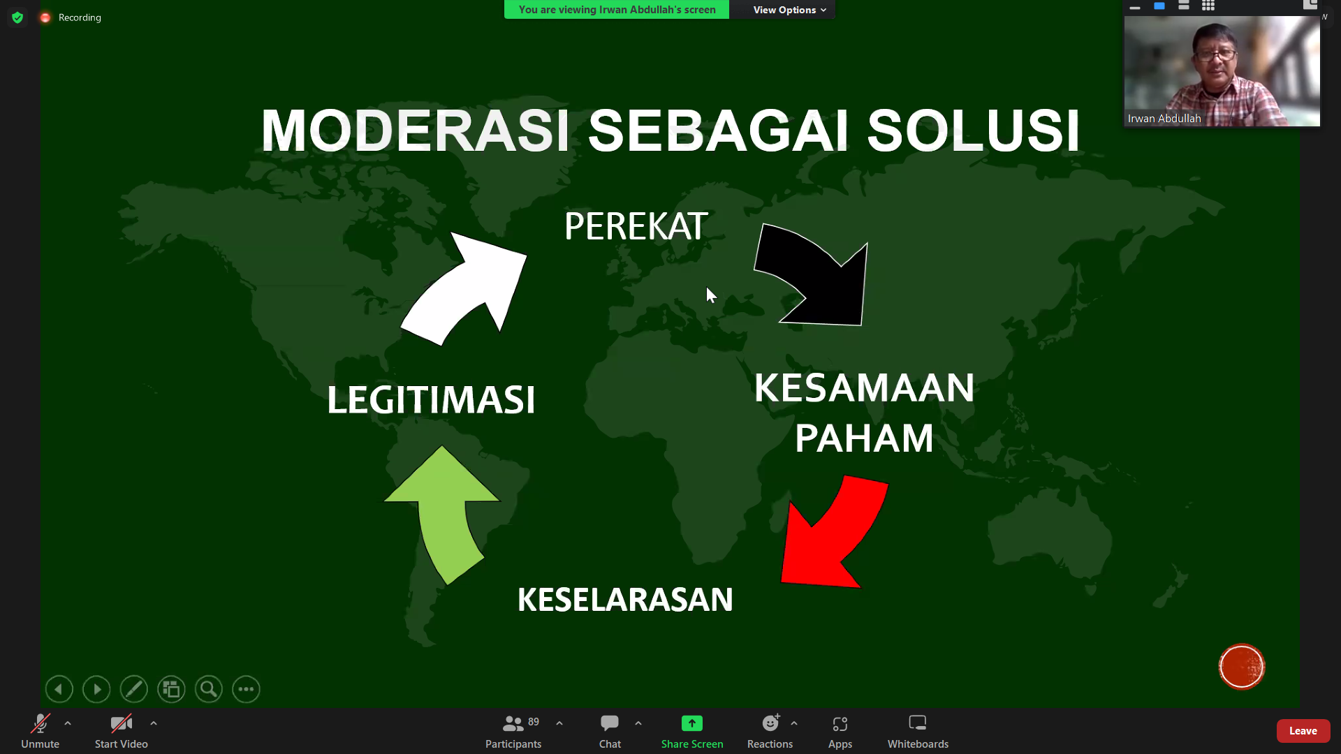
Bendera partai 2 | Bendera partai Indonesia Maju Mundur yang tidak sedikit memunculkan kontroversi dalam bentuk simbol dan bahasa yang digunakan.
Bendera partai 3 | Bendera partai Indonesia Maju Mundur yang tidak sedikit memunculkan kontroversi dalam bentuk simbol dan bahasa yang digunakan.
Source. Field observation/social media.

Discussion
The discussion section is written using Times New Roman font, 11 pt, with 1.15 spacing. It consists of six paragraphs, each comprising a minimum of 10 and a maximum of 15 lines. The first paragraph explains the main findings of the study. The second paragraph analyzes the variations of the main findings by categorizing them into cases, phenomena, realities, or trends. The third paragraph provides a theoretical interpretation of these variations within the context of Islamic law. The fourth paragraph explains the causality of the theoretical interpretation from a criminological perspective. The fifth paragraph compares the identified causal patterns with those found in other studies involving similar cases, phenomena, realities, or trends. The sixth paragraph presents research recommendations in the form of conceptual contributions, methodological approaches, or policy solutions.

Conclusion
The conclusion is written in Times New Roman, 11pt, with 1.15 spacing. The conclusion consists of three paragraphs, each paragraph written in a minimum of 10 lines and a maximum of 15 lines. The first paragraph presents important findings relevant to the study’s focus or questions. The second paragraph explains the study’s conceptual significance and the methods and theories relevant to the study’s subject. The third paragraph contains the weaknesses of the study that will become recommendations to be responded to by future studies.

AI Acknowledgment (Required: Please choose from the two statements)
Authors are required to provide an honest and transparent statement regarding the use of artificial intelligence (AI) as part of academic ethical standards, specifying whether AI was used for language editing, clarity enhancement, reference support, or other purposes, while affirming that all analyses, interpretations, and findings remain the sole responsibility of the authors.
A. If no AI technology (this includes sites like Grammarly, ChatGPT, DeepL, etc. for grammar, punctuation, fluency, translation) was applied, please use the following statement:
- The authors declare that generative AI or AI-assisted technologies were not used in any way to prepare, write, or complete this manuscript. The authors confirm that they are the sole authors of this article and take full responsibility for the content therein, as outlined in COPE recommendations.

B. If AI technology was used in any way (including to improve grammar, punctuation, fluency, etc.), please use the following statement:
- The authors acknowledge the use of [insert name of AI system(s)] to [specific use of artificial intelligence]. The prompts used include [list of prompts]. The output from these prompts was used to [explain use]. While the authors acknowledge the usage of AI, they maintain that they are the sole authors of this article and take full responsibility for the content therein, as outlined in COPE recommendations.

Disclosure of Interests (Required: Please confirm or revise statement)
Authors are required to provide a statement declaring whether any conflicts of interest exist. If no conflicts are present, it should be clearly stated that there are no financial, personal, or institutional interests that could influence the research. If conflicts do exist, they must be transparently disclosed, including the nature of the relationship, funding sources, affiliations, or any other factors that may potentially affect the objectivity, interpretation, or integrity of the study.
“The authors declare that there is no conflict of interest.”
Funding
If funding is available, it should be clearly acknowledged by identifying the source of financial support and appropriately recognizing the funding institution. However, if no funding was received, it is sufficient to state that this research was conducted without any financial support.

References
References are written using the Mendeley application with APA 7th Edition (American Psychological Association) citation style, Arial font, 10 pt, spacing 1. The citations of journal articles, books, and web pages can be seen in the example below.
Journal article (single author)

Luxton, C. (2016). Tea: Hydration and other health benefits. Primary Health Care, 26(8), 34-42. https://doi.org/10.7748/phc.2016.e1162

Journal article (2 authors)

Aspy, D. J., & Proeve, M. (2017). Mindfulness and loving-kindness meditation: Effects on connectedness to humanity and the natural world. Psychological Reports, 120(1), 102-117. https://doi.org/10.1177/0033294116685867

Journal article (3 or more authors)

Wilmott, C., Fraser, E., & Lammes, S. (2018). 'I am he. I am he. Siri rules: work and play with the Apple Watch', European Journal of Cultural Studies, 21(1), 78-95836-839

Book

Power, J. (2011). Movement, knowledge, emotion: Gay activism and HIV/AIDS in Australia. ANU Press. https://www.doabooks.org/doab?func=search&query=rid:15033

Book Chapter

Scerri, M., & Presbury, M. (2022). The power of words: A case study of service language in an Australian five-star hotel. In S. M. Perry (Ed.), Case based research in tourism, travel, hospitality and events (pp. 117-133). Springer. https://doi. https://doi.org/10.1007/978-981-16-4671-3_7

Newspaper

Spring, A., & Earl, C. (2018). 'Just not blond': How the diversity push is failing Australian fashion. The Guardian: Australia Edition. https://www.theguardian.com/fashion/2018/may/22/just-not-blonde-how-the-diversity-push-is-failing-australian-fashion

Webpage

Johnson, A. (2018, 24 May). "It doesn't need to be this way": The promise of specialised early intervention in psychosis services. IEPA. https://iepa.org.au/network-news/it-doesnt-need-to-be-this-way-the-promise-of-specialised-early-intervention-in-psychosis-services/

